Warehouse Management System



LAPP India

Software Requirement Specification (SRS)

Project ID:

The document details the summary of solution architecture and approach for the development of Warehouse Management System for LAPP India. The document is based on the inputs, system study, discussions and meeting held between BCI & LAPP India Teams.

**Prepared By: Leena Patil**

**Submission Date: 10- 11-2022**

**Version: 1.0**

BAR CODE INDIA, 691 Udyog Vihar Phase V, Gurugram, Haryana-122016, PH: 0124 4337555

|  |  |  |  |  |
| --- | --- | --- | --- | --- |
| REVISION NO. | DATE | PREPARED BY | REVIEWED BY | COMMENT |
| 1.0 | 10-11-2022 | Leena Patil | Ashutosh Kroria | SRS Document for LAPP India. |

REVISION HISTORY

**Abbreviations:**

|  |  |
| --- | --- |
| **Name** | **Abbreviation** |
| LAPP India. | LAPP |
| Bar Code India | BCI |
| Systems, Applications & Products in Data Processing | SAP |

Table of Contents

1 Specification Organization 2

2 Introduction 3

2.1 Intended Audience and Reading Suggestions 3

2.2 Project Scope 4

3 Software/Hardware Requirements 5

3.1 Central Server Configuration/Database Servers 5

3.2 Client Server Configuration (Both DB and Application) 5

3.3 Computers 5

3.4 AIDC Hardware 5

4 Solution Architecture 6

5 User Interface Specification Conventions 7

6 System Log 8

6.1 Error Logs 8

6.2 Audit Logs 8

7 Architectural Design 9

7.1 Web Application 9

7.2 Device Application 9

7.3 Scheduler Application 9

7.4 Edge Application – RFID based 9

8 Application Modules 10

8.1 Application Login- Web & Device Application 10

8.2 User Management 11

8.2.1 User Master 11

8.2.2 User Rights/ Permission 13

8.2.3 Group Master 14

8.3 Masters 15

8.3.1 Warehouse Master 15

8.3.2 Drum Type Master 16

8.3.3 Rack Location Master 17

8.3.4 Material Master 18

8.3.5 Plastic Crate Master 19

8.3.6 Pallet Master 20

8.4 Warehouse Operation 21

8.4.1 FG/Plant Warehouse Receiving 21

8.4.2 Trading Warehouse Receiving 23

8.4.3 Palletization 27

8.4.4 Putaway 29

8.4.5 Picklist Generation 31

8.4.6 Picking 33

8.4.7 Cutting Area/ Partial Picking 36

8.4.8 Packing 38

8.4.9 Staging Putaway 41

8.4.10 Dispatch 43

8.4.11 Bin to Bin Transfer 46

8.4.12 Location Optimization/Space utilization 48

8.5 Reports 49

8.6 Dashboard using Power BI 49

9 SAP Connection: 50

10 SRS Scope Change Process 51

10.1 Before Sign Off 51

10.2 After Sign Off 51

10.3 SRS Acceptance 51

# Specification Organization

The objective of this document is to supply underlying concepts, procedures, and formats used in the design, development and installation of this software application. This specification consists of three sections organized as follows:

**Section 1: Introduction**

This section provides hardware requirements and documentation conventions.

**Section 2: User Interface**

This section depicts screen design and logic flow, and is categorized into two groups:

* Application Function Module
* Common Routine

**Section 3: System Architecture**

This section provides information of system architecture.

# Introduction

## Intended Audience and Reading Suggestions

The scope of this document is to provide the understanding of this solution to user & development teams associated with the application development & implementation.

This document major emphasizes on providing clear understanding of Traceability System.

This solution comprises of:

* Web Application
* Android Device Application
* Scheduler Application
* Reader Edge Application

## Project Scope

The scope of the project is to create Warehouse Management System (WMS) Application for Lapp India Private Ltd. using RFID & AIDC Technology which will facilitate the automation of all manual operations required in handling and tracking the flow of the Cable Drum from Production Area to Warehouse and managing the flow of Accessory Packs and Trading Material at its respective Warehouses.

The application will be developed for Cable Drum Production area & Warehouse, Accessory Pack and Trading Material Warehouses respectively.

**Cable Drum Plant**: The proposed solution will provide a procedure to automate the Production & Warehouse Area operations for Cable Drum Plant using RFID & AIDC Technology. At production area, Batch Label & RFID Tags will be generated for each Cable Drum against Production Plan for tracking the same at later stages. Once identification is done, Cable Drum will be moved to Warehouse.

At Warehouse, the proposed solution keep monitoring and tracking of the Cable Drums and manage warehouse operations like Palletization, Putaway, Picking, Packing and Dispatch of Cable Drums. In case of partial picking, Pallets will be moved to Cutting Area for Cable cutting and loading (on a new Cable Drum) process. The Cable Drums / Pallets will be validated via RFID Portals when passed through dispatch area entry/ exit gates.

**Accessory Plant:** The proposed solution will keep monitor and track of the Accessory Pack and manage warehouse operations like Receiving, Putaway, Picking, Packing and Dispatch of Accessory Pack to concerned Customers. RFID Tags will be provided to each Accessory Pack received against Purchase Order and track the same at later stages.

**Trading Plant:** The proposed solution will keep monitor and track of the Trading Material and manage warehouse operations like Receiving, Putaway, Picking, Packing and Dispatch of Trading Material to concerned Customers.

The application will keep record of Cable Drum, Accessory Pack & Trading Material at each stage and update associated transaction data on server in real time. It will be integrated with SAP in order to get and post required data from SAP. The solution will be proved beneficial for Lapp India Private Ltd. as it aims to improve data accuracy, increase processing speed, eliminates paperwork, reduces time & effort required for the activity and provide instant inventory and other types of pertinent reports.

*\*NOTE: The proposed solution will be applicable for all Material packaging i.e. Cable packed in Wooden Cable Drum, Poly cover And Plastic Cover and Accessories packed in Poly Cover and Wooden Box.*

# Software/Hardware Requirements

Below are the hardware and the software requirements of the application:

## Central Server Configuration/Database Servers

The solution would require the high performance server with minimum of following:

*\*Need to be discussed*

It is recommended that Lapp India Private Ltd. procure database server with expandable data storage capacity since the volume of data generated would increase with increase in the daily transactions. The exact amount of data generated shall be visible after pilot test of entire cycle of the system.

## Client Server Configuration (Both DB and Application)

The solution would require the high performance server with minimum of following:

*\*Need to be discussed*

## Computers

Desktop would require following specifications:-

* I5/i7 Processor with Windows 10 operating System
* 8 GB RAM
* 100GB HDD
* Dot net Framework 4.5

## AIDC Hardware

* Barcode Printer
* Android Mobile Device

*\*Need to be changed as per application*

# Solution Architecture

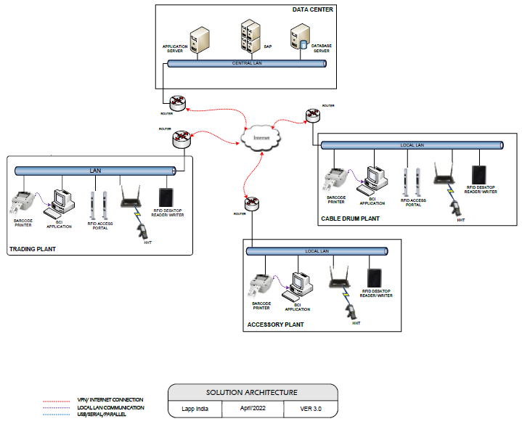

# User Interface Specification Conventions

This section specifies the user interface portion of the application.

**Section Organization**

The User Interface Specification presents screen displays or “**Dialogs**”.

**Documentation Conventions**

This section incorporates illustrations of the application user interface. Each screen display “Dialog” consists of the screen display image, a process name, a paragraph documenting the processing required for the dialog, a paragraph listing the navigation options, and a table listing for each variable field on the dialog, its database source or destination, format, and any instructions required to process the field.

The following section contains a sample dialog with each area identified.

# System Log

System shall maintain internal logs for application.

## Error Logs

These logs will contain any errors encountered during runtime for faster resolution of any problem post deployment.

## Audit Logs

These logs will monitor the activities of user who accessed the application, made changes to File/ Document and the time stamp of these activities.

# Architectural Design

Overall System consists of:

* Web Application
* Device Application
* Scheduler Application
* Edge Application – RFID based

## Web Application

A Web Application will be developed for performing transactions like Master Creations, for providing Identification to Location, Material and Pallet, Receiving, Picklist Generation, Quality Check and other activities.

## Device Application

This application will include transactions including Putaway, Picking, etc. Application will directly communicate with user input and process the request to communication server.

## Scheduler Application

A Scheduler application will be developed which will communicate with the SAP Server. The Scheduler application will run on set time interval to fetch and post the required data to/ from SAP via API. It should always be running in background while using the application.

## Edge Application – RFID based

This application will user to manage the RFID reader. Roll of application to connect the reader, enable the RFID inventory, Filter the duplicate tag and collect the appropriate tag id for processing.

# Application Modules

## Application Login- Web & Device Application

This login module will provide access to the application modules. Here the admin/user needs to enter the login detail to enter in the application and to perform the desired actions.



**Process:** User needs to enter the User Name/ID and Password in display fields and press the Login button. Application will validate the user credential.

*User will be able to view only those screens/ modules of which he has been given access rights to.*

**Validation**

* User Name/ ID will be unique for all users.
* User Name/ ID and Password length will be set.

After successful login application menu screen will appear; this screen will have the Master and Transaction options etc.

## User Management

The module will let application administrator to manage the Users, and the rights assigned to the same; the rights will define authorized application access of users.

The User Management & Master data will be created using **Web Application.**

### User Master

This module will let user to create application users who will access the application. The master will store the users’ details in system.

|  |  |
| --- | --- |
| **Data Fields** | 1. User ID 2. User Name 3. Description 4. Password 5. Email 6. Address 7. Contact 8. Active/ Inactive |
| **Process Steps** | 1. Enter required details i.e. User ID, User Name, Description, Password in system. 2. Email, Address, Contact are optional data fields. 3. Check the Active checkbox to make the user active. 4. Click on Save button to save details in database. 5. Newly added user will appear in data grid. |
| **Functions** | 1. Add, edit/update, delete as per requirement. 2. User ID and Password is used to access the application. |
| **Role** | Admin will create/ add user details via web application. |
| **Sample Screen** |  |

### User Rights/ Permission

This module will let admin to assign module / screen access rights to the application users. Once assigned, authorized users can access the application. Once permissions are assigned, user will be able to view only those screens/ modules of which he has been given access rights to by Admin.

|  |  |
| --- | --- |
| **Data Fields** | 1. User ID/ Name 2. Module /Screen Names |
| **Process Steps** | 1. Admin will select User Name/ID. 2. Screen/ module names will appear in data grid along with checkbox. 3. Admin will check the checkbox against module/ screen to which selected User should be assigned access permissions. 4. Save and Update the details in database. |
| **Functions** | Add, Edit/Update as per requirement. |
| **Role** | Admin / Authorized User will assign access rights to the selected User. |
| **Sample Screen** |  |

### Group Master

The module will be used to save the Group details in database. Using this module user can update or delete a Group details.

|  |  |
| --- | --- |
| **Data Fields** | 1. Group Code 2. Group Description 3. Is Active |
| **Process Steps** | 1. Enter Group Code. 2. Enter group Description. 3. Select ‘Is Active’ status as Yes or No. 4. Save and update the details in database. |
| **Functions** | Add, edit/update as per requirement. |
| **Role** | Admin/authorized user will add/edit group details. |
| **Sample Screen** |  |

## Masters

### Warehouse Master

The module will be used to save the warehouse details in database. Using this module user can update or delete a Plant details.

|  |  |
| --- | --- |
| **Data Fields** | 1. Warehouse Code 2. Warehouse Description 3. Is FG warehouse 4. Is RFID Enabled 5. Is Active |
| **Process Steps** | 1. Enter Warehouse Code. 2. Enter Warehouse Description. 3. Select Is FG warehouse i.e if it is FG warehouse or not. 4. Select Is RFID Enabled i.e if RFID is enabled or not. 5. Select Is Active as Yes or No i.e. drum type is active or not. 6. Save and update the details in database. |
| **Functions** | Add, edit/update as per requirement |
| **Role** | Admin/authorized user will add/edit Plant details. |
| **Sample Screen** |  |

### Drum Type Master

The module will be used to save the Drum Type details in database. Using this module user can update or delete a Drum Type details.

|  |  |
| --- | --- |
| **Data Fields** | 1. Drum Type 2. Description 3. Height 4. Width 5. Length 6. Is Active Status i.e. Yes/ No |
| **Process Steps** | 1. Enter Drum Type. 2. Enter Description. 3. Enter Height, Width, and Length of the Drum. 4. Select Is Active as Yes or No i.e. drum type is active or not. 5. Save and update the details in database. |
| **Functions** | Add, edit/update as per requirement |
| **Role** | Admin/authorized user will add/edit Drum Type details. |
| **Sample Screen** |  |

### Rack Location Master

This module will be used to save Location details in database and provide identification to them by printing unique Barcode labels.

|  |  |
| --- | --- |
| **Data Fields** | 1. Location Code 2. Name 3. Location Type- Import, Domestic/Accessories 4. Zone 5. Height 6. Width 7. Weight 8. Staging Location i.e. Warehouse/ Staging Area 9. Is Active Status i.e. Yes/ No |
| **Process Steps** | 1. Enter Location Code and Name. 2. Select Location Type i.e. Import or Rejected. 3. Enter Zone. 4. Enter Height, Width, and Weight. 5. Select Staging Location i.e. Warehouse/ Staging Area from dropdown. 6. Select Is Active as Yes or No i.e. location is active or not. 7. Print label for location. 8. Paste label on location. 9. Save the details in database. |

|  |  |
| --- | --- |
| **Functions** | Add, edit/update and delete Location details as per requirement. |
| **Sample Screen** |  |

### Material Master

The module will be used to view the Material details downloaded from SAP.

|  |  |
| --- | --- |
| **Data Fields** | 1. Material Code 2. Description 3. QA Status – Accepted/Rejected 4. Material Type 5. UOM 6. Manufacturing Date 7. Expiry Date 8. Size |
| **Process Steps** | 1. Material Master screen will be visible to authorized personnel only. 2. BCI application will download Material details from SAP. 3. Downloaded Material details such as Material Code, Description, QA status, Material type, UOM, etc. details will get displayed in data grid on screen. |
| **Functions** | View details of the Material master. |
| **Sample Screen** |  |

### Plastic Crate Master

The module will allow user to add, edit or delete Plastic Crate details.

|  |  |
| --- | --- |
| **Data Fields** | 1. Crate ID 2. Description 3. Capacity 4. Is Active i.e. Yes/ No |
| **Process Steps** | 1. Enter Crate ID. 2. Enter Description of the Crate. 3. Enter Capacity of the Crate. 4. Select Is Active as Yes or No i.e. Crate is active or not. 5. Save the Crate details in database. |
| **Functions** | Add, edit/update, and delete Crate details as per requirement. |
| **Sample Screen** |  |

### Pallet Master

The module will be used to store the Pallet details in database. User can add, edit or delete the Pallet details.

|  |  |
| --- | --- |
| **Data Fields** | 1. Pallet ID 2. Description 3. Height 4. Width 5. Length 6. Pallet Capacity 7. Is Active |
| **Process Steps** | 1. Enter Pallet ID and Description of the Pallet. 2. Enter Height, Width, and Length of the pallet. 3. Enter the Pallet Capacity. 4. Select Is Active as Yes or No i.e. Pallet is active or not. 5. Save Pallet details in database. |

|  |  |
| --- | --- |
| **Functions** | Add, edit/update and delete Pallet details as per requirement. |
| **Sample Screen** |  |

## Warehouse Operation

### FG/Plant Warehouse Receiving

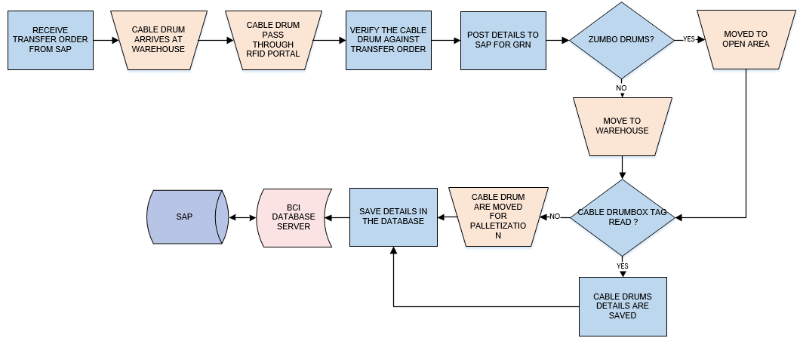

**Activities**

|  |  |
| --- | --- |
| **Module Description** | This module will be used to transfer the material (Cable Drums) from Production Area to Warehouse against Transfer Order and save the corresponding receiving details in database.  Receiving details are posted to SAP for GRN generation.  ***\*This activity will be done using RFID Portal Desktop Application and Handheld devices.*** |

|  |  |
| --- | --- |
| **Pre-Conditions** | 1. Cable Drum shall arrive at FG warehouse. 2. Drum/box should contain the Batch RFID Tag. 3. Each drums contains the Unique Batch No. 4. Transfer Order should be received from SAP 5. Cable drum tag should be present. 6. GET_API will be required to fetch Transfer Order details from SAP. 7. POST_API will be required to post receiving details to SAP for auto Material receipt note and will be provided by Lapp India. |

|  |  |
| --- | --- |
| **Process Steps** | 1. Receive Transfer Order from SAP. 2. Cable drums arrives at Warehouse. 3. RFID Portal at entry Gates will read the Cable drums tag (Batch No). 4. Verify the received Cable Drums against Transfer Order. 5. Post details to SAP for GRN. 6. Zumbo drums will move to open area and small drums/boxed will move to warehouse. 7. In case, any Cable drum/Box tag is not read, the drums will move for Palletization and pass through RFID Tunnel for further reading. 8. Save the details in database. |

|  |  |
| --- | --- |
| **Post-Conditions** | Inventory details will get updated in database.  GRN details are auto generated in the SAP. |

|  |  |
| --- | --- |
| **Validations** | 1. Production confirmation should be done for batch no. 2. An alert should be displayed in case duplicate/ invalid tag is scanned. 3. An alert should be displayed in case of invalid activity. |

|  |  |
| --- | --- |
| **Sample Screen** |  |

### Trading Warehouse Receiving

#### Label Printing for Import and Non RFID material

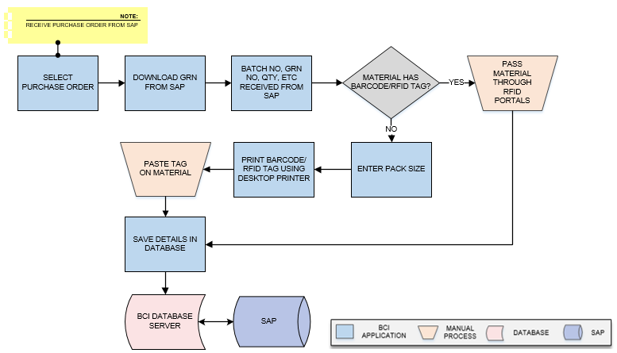

**Activities**

|  |  |
| --- | --- |
| **Module Description** | A unique RFID Tag for batch no. will be generated for each received Material (Accessory, Drum etc.) and corresponding details will get updated in the database. This process will be optional and used only for Import and non RFID material.  ***\*This activity will be done using Device Application.*** |

|  |  |
| --- | --- |
| **Pre-Conditions** | 1. Material is received at Trading warehouse. 2. GET_API will be required to pull/ fetch GRN details from SAP and same will be provided by LAPP India. |

|  |  |
| --- | --- |
| **Process Steps** | 1. Download GRN from SAP. 2. Batch No, GRN No, Material Code, Quantity, Length, MFG Date received from SAP. 3. Select the GRN No. 4. Select the Material and Batch No. 5. If received material is non-barcoded/RFID Tag:    1. Enter pack size.    2. Print Barcode/RFID Tag using desktop printer.    3. Paste Tag on Material. 6. If material has barcode/RFID tag:    1. Pass material through RFID Portals for verification. 7. Save details in the database. |

|  |  |
| --- | --- |
| **Post-Conditions** | 1. Material with label will be moved for palletization. |

|  |  |
| --- | --- |
| **Validations** | 1. An alert should be displayed in case duplicate/ invalid tag is printed. 2. An alert message is displayed in case of any error / invalid activity. |

|  |  |
| --- | --- |
| **Sample Screen** |  |

#### Portal Movement



**Activities**

|  |  |
| --- | --- |
| **Module Description** | This module will let user to verify the received drums/ material using portal and save the details in database. This process will be done only for the new material.  ***\*This activity will be done using Device Application and RFID portal.*** |

|  |  |
| --- | --- |
| **Pre-Conditions** | 1. Received material should have Barcode/RFID tag. 2. RFID Portals should be installed. 3. GRN details should be fetched from SAP. 4. GET_API will be required to pull/ fetch GRN details from SAP and same will be provided by Lapp India. |

|  |  |
| --- | --- |
| **Process Steps** | 1. Select GRN No in portal. 2. Batch No, GRN No, Material Code, Quantity, Length, MFG Date received from SAP. 3. Verify the details of the received material.   *\*Verification will be done by HHT/Portal.*   1. Save details in the database. |

|  |  |
| --- | --- |
| **Post-Conditions** | 1. Material is verified and will be moved for palletization. |

|  |  |
| --- | --- |
| **Validations** | 1. An alert should be displayed in case duplicate/ invalid GRN is entered. 2. An alert message is displayed in case of any error / invalid activity. |

|  |  |
| --- | --- |
| **Sample Screen** |  |

### Palletization

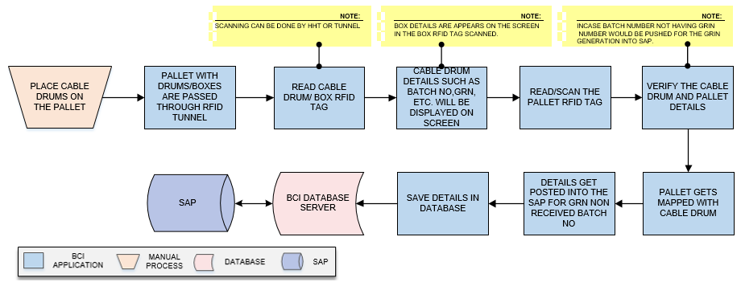

**Activities**

|  |  |
| --- | --- |
| **Module Description** | This module will let user to map the details of the cable drums with the pallet and passed through the tunnel as suggested by system and update the mapping details in database.  ***\*This activity will be done using Device and Desktop Application.*** |

|  |  |
| --- | --- |
| **Pre-Conditions** | 1. Pallet/Drums should have RFID tag. |

|  |  |
| --- | --- |
| **Process Steps** | 1. Place Cable drums on Pallets. 2. The Cable drums/boxes are passed through the RFID tunnel. 3. Read cable Drum/ Box RFID tag.   *\*Scanning can be done by HHT or tunnel.*   1. Cable Drum details such as Batch No, GRIN details, etc. will be displayed on the screen.   *\*Box details are appears on the screen in the Box RFID tag scanned.*   1. Read/scan the pallet RFID /Barcode. 2. Batch number are read in tunnel and gets validated with GRN details.   *\*Incase batch number not having GRN number would be pushed for the GRN generation into SAP.*   1. Pallet details with Cable Drum are mapped in the database. 2. Details get posted into the SAP for GRN non received batch no. 3. Details saved in database. |

|  |  |
| --- | --- |
| **Post-Conditions** | 1. Pallet details are saved in database. 2. Based on drum type system will calculate the dimension of filled pallet 3. Pallet and drums are mapped and details saved in the database.   Pallets are moved for Put away in warehouse. |

|  |  |
| --- | --- |
| **Validations** | 1. An alert should be displayed in case duplicate/ invalid Pallet tag is entered. 2. An alert should be displayed in case duplicate/ invalid Cable drum details are entered. |

|  |  |
| --- | --- |
| **Sample Screen** |  |

### Putaway

**Activities**

|  |  |
| --- | --- |
| **Module Description** | This module will let user to place Pallet on available storage location in FG Warehouse as suggested by system and update the Pallet - Location mapping details in database. This process will be done only for the new material.  ***\*This activity will be done using Device Application.*** |

|  |  |
| --- | --- |
| **Pre-Conditions** | 1. Location Label Printing and pasting should have been done using the Location Master. 2. Location Types should be defined. 3. POST_API will be required to post Location-Pallet mapping details to the SAP and same will be provided by Lapp India. |

|  |  |
| --- | --- |
| **Process Steps** | 1. Read/Scan pallet RFID tag. 2. System will suggest location to user for Putaway as per Location Type  *\*Location will be suggested based on Domestic/Import and Accessories.* 3. Pallet details such as ID, Capacity, etc. will be displayed on the screen. 4. Read/scan Location Barcode Label using HHT. 5. Location details such as Location code, rack no, height etc gets displayed on screen. 6. User will place the Pallet at scanned Location. 7. The Location and Pallet mapping details are saved in the database. 8. Post mapping details to SAP. |

|  |  |
| --- | --- |
| **Post-Conditions** | 1. Location - Pallet mapping will help in Inventory Count and maintaining record of pallet. 2. Location code and Pallet details are mapped in database. 3. Consumed dimension will update against the location. |

|  |  |
| --- | --- |
| **Validations** | 1. An alert should be displayed in case duplicate/ invalid tag is scanned. 2. An alert message is displayed in case of any error / invalid activity. |

|  |  |
| --- | --- |
| **Sample Screen** |  |

### Picklist Generation

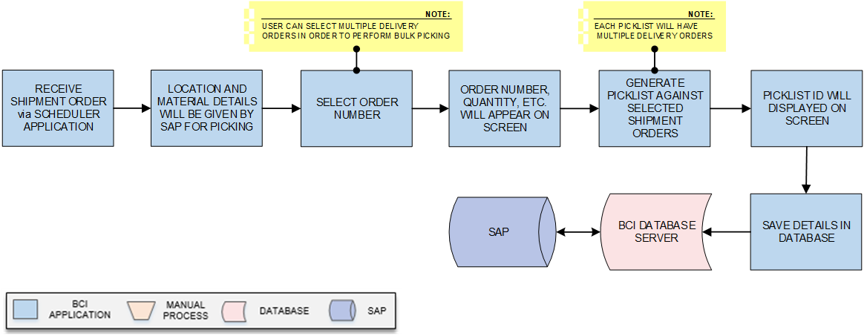

**Activities**

|  |  |
| --- | --- |
| **Module Description** | The module will be used to create Picklist against Shipment Order having multiple Delivery Orders received from SAP. A unique Picklist ID will get generated.  ***\*This activity will be done using Web Application.*** |

|  |  |
| --- | --- |
| **Pre-Conditions** | 1. Shipment Order shall be received via Scheduler application. 2. GET_API will be required to fetch/ pull Delivery Order details from SAP and will be provided by Lapp India. |

|  |  |
| --- | --- |
| **Process Steps** | 1. Receive Shipment Order from Scheduler application. 2. Material details will be suggested by SAP for picking details.   *\*The location, batch number details of material gets displayed on screen.*   1. Select Order Number.   *\*User can select multiple Delivery Orders in order to perform bulk picking.*   1. Order Number, Quantity, Description and other details will appear on screen. 2. Generate Picklist against selected shipment order.   *\*Each Picklist will have multiple Delivery Orders.*   1. Picklist ID and Location details will get displayed on screen. 2. Details are updated in the database. |

|  |  |
| --- | --- |
| **Post-Conditions** | 1. Picklist ID is generated by system. 2. User should be able to view the Picklist while Picking. |

|  |  |
| --- | --- |
| **Validations** | 1. An alert should be displayed in case of invalid activity. 2. An alert should be displayed in case Shipment Order are not available in list. 3. An alert should be displayed in case of Picklist is not generated. |

|  |  |
| --- | --- |
| **Sample Screen** |  |

### Picking

**Activities**

|  |  |
| --- | --- |
| **Module Description** | The module will be used to pick Cable Drum against selected Picklist from the locations suggested. System will verify the Cable Drum against Picklist and details for the same will be updated in database.  ***\*This activity will be done using Device Application.*** |

|  |  |
| --- | --- |
| **Pre-Conditions** | 1. Cable Drum should have label. 2. Locations should have barcode label. 3. Mobile Device should be available. 4. Picklist should be created. 5. Picklist ID/ Delivery Order should be available in list. 6. POST_API will be required to post/ push picking details to SAP and will be provided by Lapp India. |

|  |  |
| --- | --- |
| **Process Steps** | 1. Select Picklist ID/Delivery Order Number in HHT. 2. Picklist details i.e. Picklist ID, Description, Quantity, Location Code, Batch Number, etc. will get displayed on screen. 3. System will suggest location from where material (Cable Drum, Accessories) is to be picked.   *\*System will always suggest the Location with greater or equal quantity of material mentioned in Picklist.*   1. If material to be picked is “Cable Drum”: 2. Scan the Location/ Pallet Barcode Label using Device 3. Location details such as Location Code, Type, Name, etc. will be displayed on the screen. 4. Pull down the pallet from the rack/location. 5. Read/Scan the Cable Drum RFID tag/ label. 6. User will pick Cable Drum from Pallet.   *\*Cable Drum should be placed in such a manner that RFID Tag is faced outside.*   1. User will move drum to Cutting Area in case Cable cutting/ partial picking is required (order quantity is less than drum quantity).   *\*Kindly refer to Cutting Area/ Partial Picking module for this activity.*   1. Pallet will cross RFID access portals. 2. Placed the pallet in same location after cutting. 3. System will auto-capture Pallet Tag details   *Inventory will be updated.   1. If material to be picked is “Accessories”: 2. Scan Location Barcode Label 3. Read and pick Crate Tag 4. If partial picking is required: 5. Read Accessory Pack RFID Tag 6. Enter quantity to be picked 7. Place picked quantity in new box 8. Print RFID Tag using RFID mobile printer and paste on box. 9. Balance Crate quantity will get updated 10. User will move crate to old location suggested by system for balance 11. Move Accessory for Packing 12. Save details in the database. 13. Post picking details to SAP. |

|  |  |
| --- | --- |
| **Post-Conditions** | 1. Cable drums which are picked can be move for packing. 2. Inventory should get updated as per picking. 3. Rack/Pallet dimension get auto updated. |

|  |  |
| --- | --- |
| **Validations** | 1. An alert should be displayed in case duplicate/ invalid barcode/tag is scanned. 2. An alert should be displayed if Picklist is not available in list. 3. An alert should be displayed if wrong Cable Drum is picked. |

|  |  |
| --- | --- |
| **Sample Screen** |  |

### Cutting Area/ Partial Picking

**Activities**

|  |  |
| --- | --- |
| **Module Description** | The module will be used to cut and rolled (loaded) the received material on a new Cable/ in a pack. A unique identification with same Batch Number will be provided to each Cable using Batch Label & RFID Tag and corresponding details will be updated in the database.  This will be an optional activity and used only when cutting of material (cable) is required.  ***\*This activity will be done using Device Application.*** |

|  |  |
| --- | --- |
| **Pre-Conditions** | 1. Cable Drum should have label/ RFID Tag. 2. HHT Device should be available. |

|  |  |
| --- | --- |
| **Process Steps** | 1. Receive Drum in Cutting Area. 2. Select Shipment Order in HHT. 3. Order details such as Order Number, Description will be displayed on the screen. 4. Read/Scan Cable RFID Tag/ label. 5. Cable details such as ID, Length, ETC. will be displayed on the screen. 6. Enter Quantity to be cut. 7. Select Output Drum Type from dropdown. 8. User will cut and load Cable on new Cable as per the quantity. 9. Print Batch Label & RFID Tag for new Cable.   *\*Batch Label and RFID Tag will be printed together via RFID printer.*   1. Paste barcode label on Cable and affix RFID tag on Drum.   *\*Batch Label & RFID Tag will have thread cut between them, in order to separate / cut.*   1. Save details in the database. 2. Move the drums as per delivery quantity for Packing. |

|  |  |
| --- | --- |
| **Post-Conditions** | 1. Cable drums will move for packing. 2. Balance Cable quantity will be updated in the database 3. Remaining (old) Cable will be moved for Putaway*.* |

|  |  |
| --- | --- |
| **Validations** | 1. An alert should be displayed in case duplicate/ invalid barcode/tag is scanned. 2. An alert should be displayed if Picklist is not available in list. 3. An alert should be displayed if wrong Cable Drum is picked. |

|  |  |
| --- | --- |
| **Sample Screen** |  |

### Packing

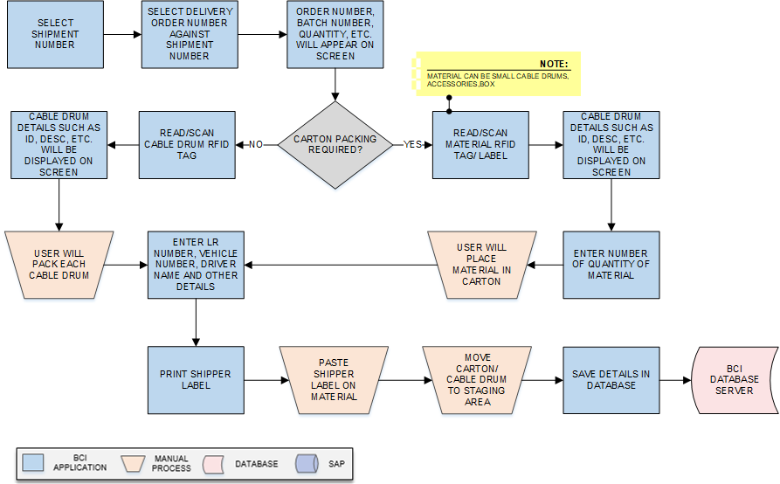

**Activities**

|  |  |
| --- | --- |
| **Module Description** | This module will help user to pack individual Cable Drum or Multiple Cable Drum in a carton against Shipment Order. Barcode Label will be printed for Carton/packed Cable Drum and corresponding packing details will be updated in the database.  ***\*This activity will be done using Device Application.*** |

|  |  |
| --- | --- |
| **Pre-Conditions** | Cable Drum should have barcode labels.  Shipment Number should be available in list.  Delivery Orders should be available.  Printer should be connected with the application  HHT device should be available. |

|  |  |
| --- | --- |
| **Process Steps** | 1. Select Shipment Number 2. Select Delivery Order against Shipment Number. 3. Order details such as Order Number, Batch Number, Description and Quantity will be displayed on the screen. 4. If Carton Packing is required:    * Read/Scan material (Cable Drum/ Accessories/ Box) label/ RFID Tag against selected Delivery Order.    * Material details such as ID, Description, etc. will be displayed on the screen.    * Enter Number of Quantity of material. 5. If Carton Packing is not required:    * Read/Scan Cable Drum RFID Tag against selected Delivery Order.    * Cable Drum details such as ID, Description, etc. will be displayed on the screen.    * User will pack each Cable Drum. 6. Enter LR Number, Vehicle Number, Driver Name and other required details 7. Print Shipper Label. 8. Paste Label on Boxes/ cable Drums 9. User will move Carton/ Cable Drum to staging area. 10. Save details in the database. |

|  |  |
| --- | --- |
| **Post-Conditions** | 1. Carton/ Cable Drum Barcode printing details will get saved in the database. 2. Packed Carton/ Cable Drum will move for Dispatch. |

|  |  |
| --- | --- |
| **Validations** | 1. An alert should be displayed in case duplicate/ invalid barcode is scanned. 2. An alert should be displayed in case Delivery Order are not available in list. 3. An alert should be displayed in case invalid Delivery Order is selected. |

|  |  |
| --- | --- |
| **Sample Screen** |  |

### Staging Putaway

**Activities**

|  |  |
| --- | --- |
| **Module Description** | This module will be used to place/store packed Cable Drum at staging storage location. Corresponding Cable Drum- Location mapping details will be updated in the database.  ***\*This activity will be done using Device Application.*** |

|  |  |
| --- | --- |
| **Pre-Conditions** | 1. Material packing should be done. 2. Shipment Label should have been printed and pasted on material. 3. Shipment Number should be available in list. 4. HHT device should be available. |

|  |  |
| --- | --- |
| **Process Steps** | 1. Select Shipment Number. 2. Corresponding material details such as Batch Number, Pack Size, Material Description, etc. will appear on screen 3. Enter/Scan Staging Location Code. 4. Read/Scan material Barcode label/ RFID Tag. 5. Place Cable Drum/ cartons at scanned Location. 6. Save Location- material mapping details in the database. |

|  |  |
| --- | --- |
| **Post-Conditions** | 1. Material should be available at the time of Dispatch. 2. Staging details should be saved in database. |

|  |  |
| --- | --- |
| **Validations** | 1. An alert should be displayed in case Shipment Numbers are not available in list. 2. An alert should be displayed in case duplicate/ invalid barcode/tag is scanned. |

|  |  |
| --- | --- |
| **Sample Screen** |  |

### Dispatch

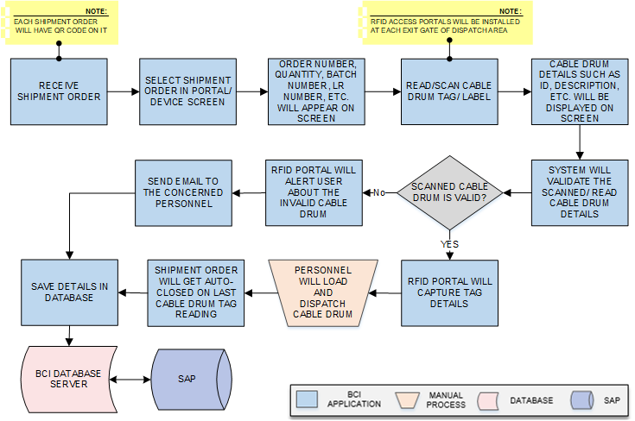

**Activities**

|  |  |
| --- | --- |
| **Module Description** | In this process, Cable Drum against particular Shipment Order will be validated and dispatched at exit gate of Dispatch area. An alert will be share to concerned user in case of any invalid Cable Drum dispatch and same will get updated in database.  ***\*This activity will be done using Device Application and RFID portal.*** |

|  |  |
| --- | --- |
| **Pre-Conditions** | Shipment Order should be available.  Picking should be complete.  HHT should be available.  RFID Portals should be installed at exit gates of Dispatch/ Loading Area. |

|  |  |
| --- | --- |
| **Process Steps** | 1. Receive Shipment Order.   *\*Each Shipment Order will have QR Code on it.*   1. Select Shipment Order in portal/ device screen. 2. Shipment details such as Order Number, Quantity, Batch Number, LR Number, Vehicle Number, etc. will be displayed on the screen. 3. Read/Scan Cable Drum/ Pallet Tag. 4. Material details such as ID, Description, etc. will be displayed on the screen. 5. In case of valid Cable Drum:  * RFID Portal will capture Tag details. * Personnel will load and dispatch Cable Drum. * On completion of material loading against Shipment Number, Shipment Order will get auto-closed.  1. In case of invalid Cable Drum:  * RFID Portal will alert user about the invalid Cable Drum. * Send email to the concerned personnel.  1. Save details in the database. 2. Post loading and dispatch details to SAP. |

|  |  |
| --- | --- |
| **Post-Conditions** | 1. Transaction details are saved in database. 2. Details should be posted to SAP. 3. In case of invalid material/ Pallet scanning, email should be sent to concerned personnel. |

|  |  |
| --- | --- |
| **Validations** | 1. An alert should be displayed in case duplicate/ invalid Cable Drum Tag is scanned.   An alert should be displayed if Shipment Order is not available in list.  RFID Portals should alert in case invalid material/ pallet is scanned |

|  |  |
| --- | --- |
| **Sample Screen** |  |

### Bin to Bin Transfer

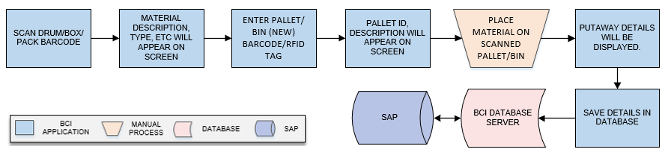

**Activities**

|  |  |
| --- | --- |
| **Module Description** | This module will be used to transfer material from one pallet to other. And update corresponding details in database.  ***\*This activity will be done using Handheld device.*** |

|  |  |
| --- | --- |
| **Pre-Conditions** | 1. Barcode/RFID tag are applied on pallet. 2. Palletization should be completed. |

|  |  |
| --- | --- |
| **Process Steps** | 1. Scan Drum/Box/Pack Barcode. 2. Material Description, Type, Size will appear on screen. 3. Enter Pallet/Bin (new) Barcode/RFID tag at which material is to be transferred. 4. Pallet ID, Description will appear on screen. 5. Place material on scanned Pallet/Bin. 6. Putaway details will be displayed for material transfer. 7. Save details in the database. |

|  |  |
| --- | --- |
| **Post-Conditions** | Material will be placed on new Pallet  Transaction details are updated in database.  New/Old pallet dimension will auto update. |

|  |  |
| --- | --- |
| **Validations** | 1. An alert should be displayed in case duplicate/ invalid Material barcode is entered. 2. An alert should be displayed in case duplicate/ invalid Pallet Barcode/RFID tag is entered. |

|  |  |
| --- | --- |
| **Sample Screen Design** |  |

### Location Optimization/Space utilization

**Activities**

|  |  |
| --- | --- |
| **Module Description** | This module will be used for space utilization. Space/location utilization will be done through bon to bin transfer and details will be saved in database.  ***\*This activity will be done with help of Bin to Bin transfer.*** |

|  |  |
| --- | --- |
| **Pre-Conditions** | 1. Barcode/RFID tag are applied on pallet. 2. Palletization should be completed. |

|  |  |
| --- | --- |
| **Process Steps** | 1. System will generate the Empty/Partial filled rack report based on Rack dimension and placed pallet dimension. 2. Based on unused space, system list out the rack locations with available space. |

|  |  |
| --- | --- |
| **Post-Conditions** | 1. Available space will be optimize for material putaway. |

## Reports

Reporting module will provide access to the data that will be helpful in making well-informed strategic decisions, reduces risk, and increases productivity. The reporting interface will be user-friendly, application users can easily generate, and view required data.

The application will generate customized reports based on required data fields and time interval selected / entered by users; Microsoft Crystal Reports/ RDLC Reports will be generated which can be exported into defined excel file/ PDF format as and when required. There would be customized reports provided to End Users.

Reports can be defined as private for restricted viewing – or made public, giving access to information based on access rights assigned to the particular user / group.

Reports

1. Warehouse Space Utilization Report
2. Picker efficiency report
3. In Transit Report (For STO)
4. Pending Put away
5. Running task (Inbound/Outbound)
6. Location Inventory report

*To be finalized. Format is required form LAPP.

## Dashboard using Power BI

Need to finalize.

# SAP Connection:

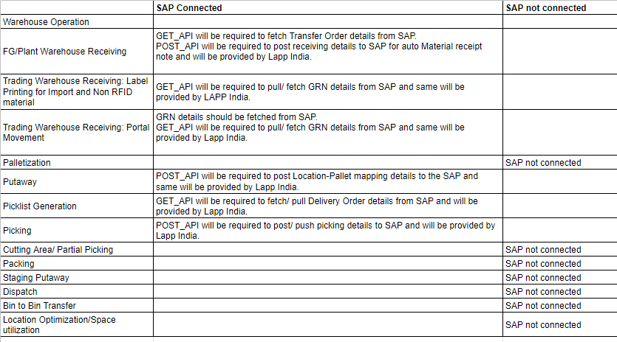

# SRS Scope Change Process

## Before Sign Off

Any changes in SRS need to be informed in writing by LAPP India. It will be incorporated / confirmed only after doing detailed feasibility study by BCI.

* If any change is out of scope then this would be done as a CR post feasibility and priority will be decided based on mutual agreement.
* Once the change is developed , any further change in the same would be considered as a CR

## After Sign Off

Any changes in proposed solution after approval of this document by LAPP India are subjected to confirmation from BCI, taking feasibility constraints into account. These changes will be incorporated (if any) into the solution only after delivering proposed solution & may be charged as extra.

* Any change in the proposed solution due to customer system design or process will be considered as CR
* Any process which is not mentioned in this document will not be considered as “mutual understanding or default presence or standard practice”.

The changes in proposed solution before & after acceptance will be mutually agreed and duly signed and accepted by LAPP India & BCI.

## SRS Acceptance

|  |  |
| --- | --- |
| **For LAPP India** | **For Bar Code India (BCI)** |
| **Name:** | **Name:** |
| **Designation:** | **Designation:** |
| **Department:** | **Department:** |

Agreed and Accepted by LAPP India and Bar Code India